UNDERSTAND WEB ARCHITECTURE AND COMPONENTS

1.1 Describe the hardware and software components which enable the internet and web

Core technologies:
- A router – A device that forwards data between networks using IP addresses
(internet protocol).

- A switch – A device that forwards data on a Local network using MAC addresses.

- A server – A data storage device that serves that data to clients on request.

How the internet works: (30 Minutes) – add a paragraph or 2
The role of DNS servers (5 minutes) – add a paragraph
How the World Wide Web works (5 minutes) – add a paragraph

(Total 40 minutes)
Add a screenshot to back up your answer (Here is a router which I could use to connect to the internet)


1.2 Explain the role of network protocols in web architecture

Describe the following protocols (30 minutes)

- TCP - – add a sentence or 2

- IP - – add a sentence or 2

- HTTP - – add a sentence or 2

- HTTPS - – add a sentence or 2

Add a screenshot to back up your answer (common internet protocols)

1.3 Explain the role of internet service providers, web hosting services and domain name registrars

- ISP: – add a sentence or 2

- Domain Name Registrar: – add a sentence or 2

- Hosting Service Provider: – add a sentence or 2
(20 Minutes)
Add a screenshot to back up your answer (a website article on role of ISP’s or DNS)

1.4 Describe available types of web components.

Hardware: (20 to 30 Minutes)
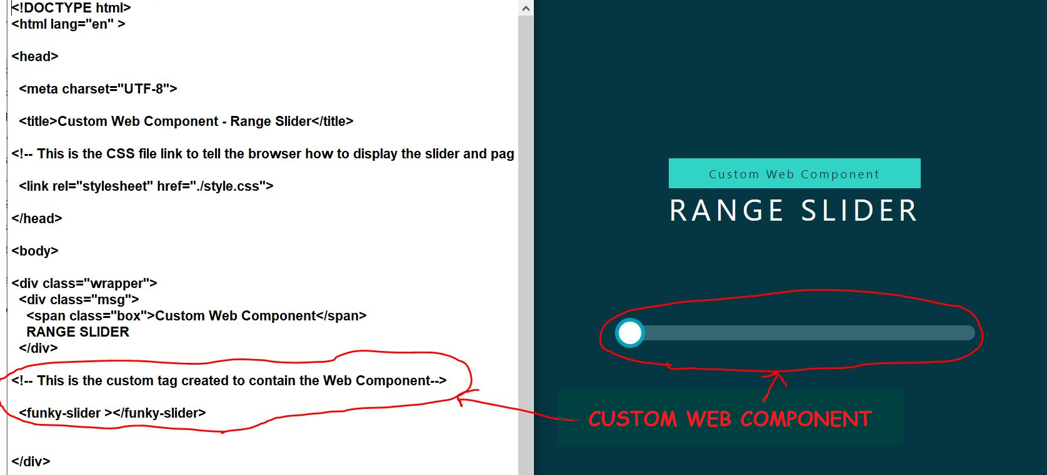
Here you can see a custom web component with all the complexity hidden in the javascript file so that we only need a custom tag set in the Html – This promotes code re-use.

(15 Minutes )

UNDERSTAND THE TECHNOLOGIES THAT CAN BE USED TO BUILD AND OPERATE A WEBSITE

2.1 Explain the use of markup languages
HTML - – add a paragraph
XML - – add a paragraph
XHTML - – add a paragraph
(20 Minutes)
Add a screenshot to back up your answer (Here is a sample page of HTML code)

2.2 Explain the use and functionality of:

Web runtime environments - – add a paragraph

web application programming languages -
Client-side Languages: Languages that run on the client and not the server.

HTML – – add a sentence

CSS – – add a sentence

Javascript – – add a sentence

Server Side Language : Languages that run on the server and supply the result to the client.

PHP - – add a sentence

Python - – add a sentence

ASP.NET - – add a sentence

(30 Minutes)
Add a screenshot to back up your answer (Here is a sample page of javascript code)

2.3 Explain the role of databases in building websites and web applications.

– add a 1-2 paragraphs – half a page of 12pt
(20 Minutes)
Add a screenshot to back up your answer (Here is a website describing the role of databases in web design)

2.4 Identify typical product stack combinations that can be used for web .
– add a 1-2 paragraphs
(30 Minutes)
Add a screenshot to back up your answer (Here is a website describing web stacks)

PRODUCE A WEBSITE DESIGN FOR A GIVEN BRIEF

Produce a proposal document for a web-site design..

Exercise - Work through this proposal and replace everything that is formatted in “Orange” Please leave formatting “as is” for your answers to aid marking process.

Identify the components required by a web-site design.

Front end elements: (customer or users)
Screenshot and 1 sentence on each

- Navigation structure (menu) - Place your sentence here and replace the screenshot (Here is a screenshot showing the main navbar…own words)

- Page layout - Place your sentence here and replace the screenshots with your own.
Ie: A blueprint of a couple pages and where things will land
(responsive design may req several)
Can be pencil drawings or mock-ups https://moqups.com/
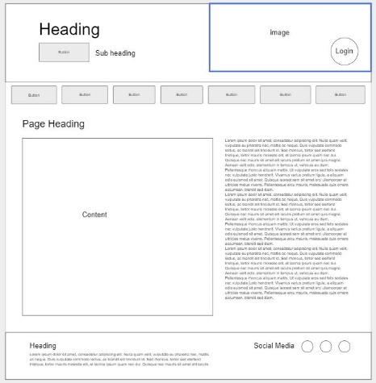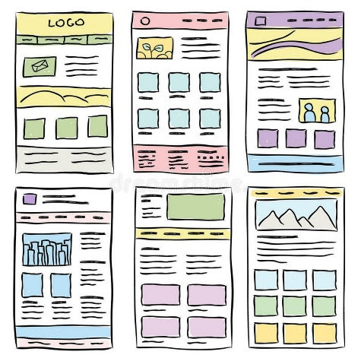

- Logo - Place your sentence here and replace the screenshot
Create a logo using Vectr - Vectr - Free Online Vector Graphics Editor

- Content (text/videos/images) - Place your sentence here and replace the screenshot
- Design - Place your sentence here and replace the screenshot (Screenshot your “Theme” choices Fonts colours etc - own words for caption)

(25 Minutes)

Backend elements (Web Developers or Administraor)
- Blog posts - Place your sentence here and replace the screenshot (Screenshot your Blog)
- Email – Here you can see I have received an e-mail via the contact form – own words for caption.
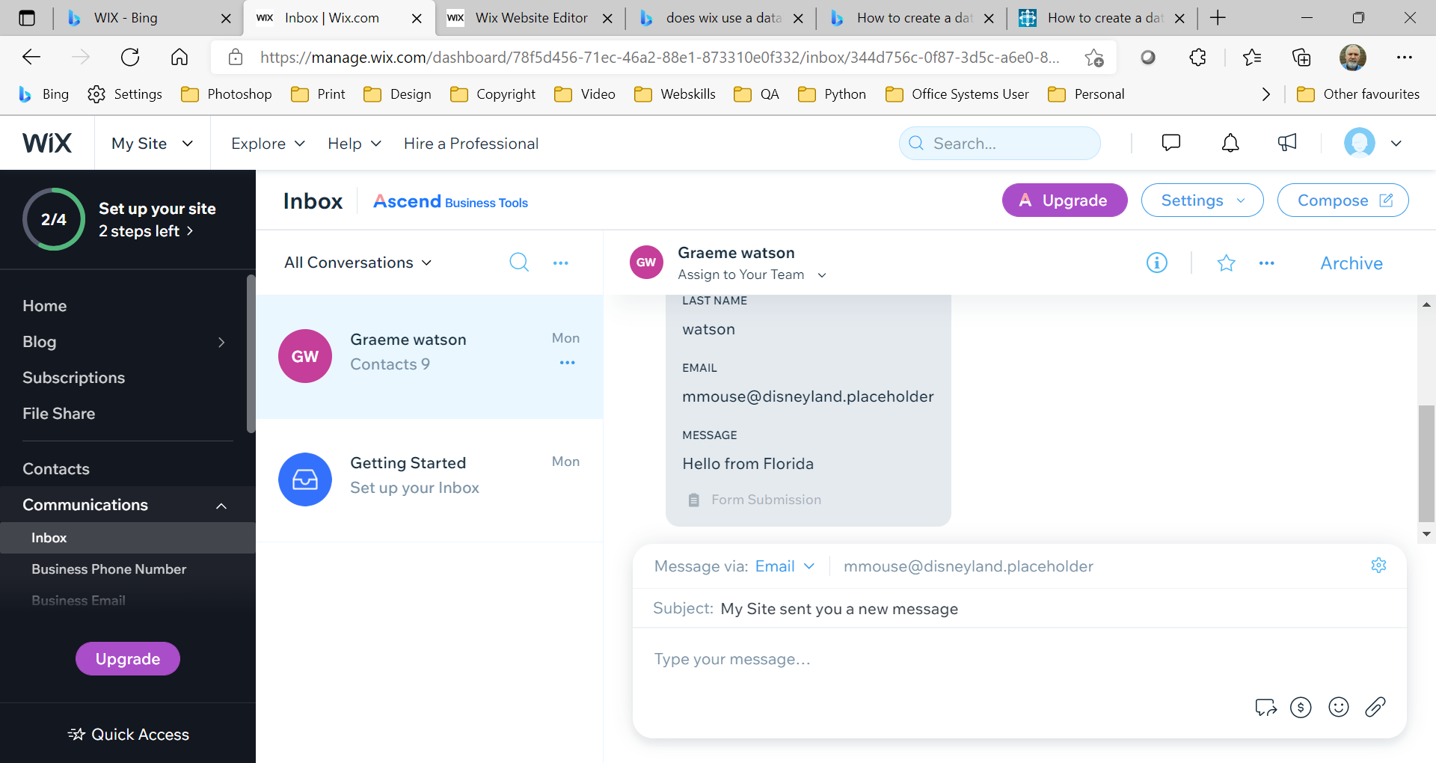

- ecommerce Whilst we had no requirement for ecommerce on our site it would be very easy to add. The screenshot below shows how to add a variety of ecommerce solutions to the website. This would in turn create new tables in the database for things like products, shipping choices etc. – own words for caption
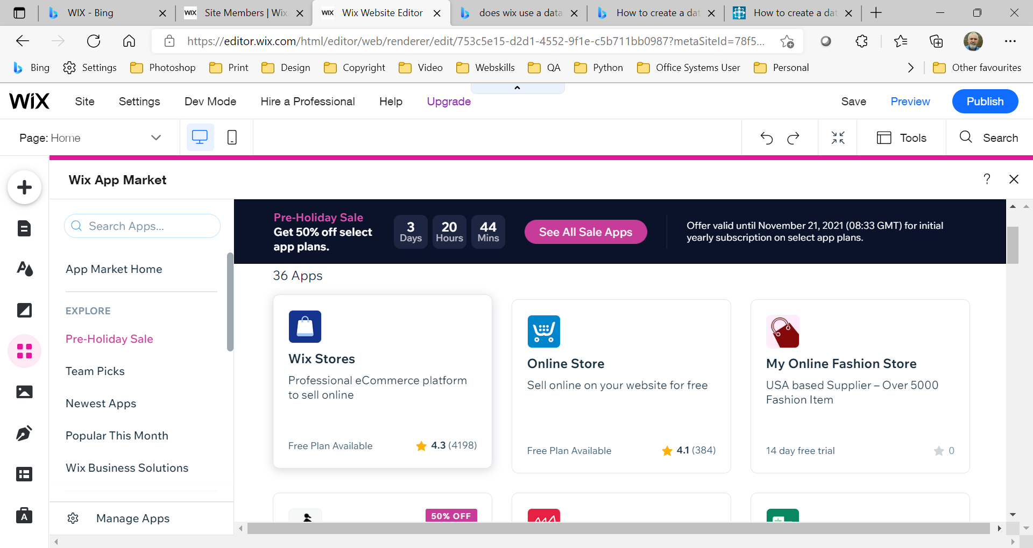
- Contact Form - Place your sentence here and replace the screenshot (Screenshot your contact form and discuss in own words)

- Database: On our website we have a database for our blog – here you can see the table containing our posts – own words for caption
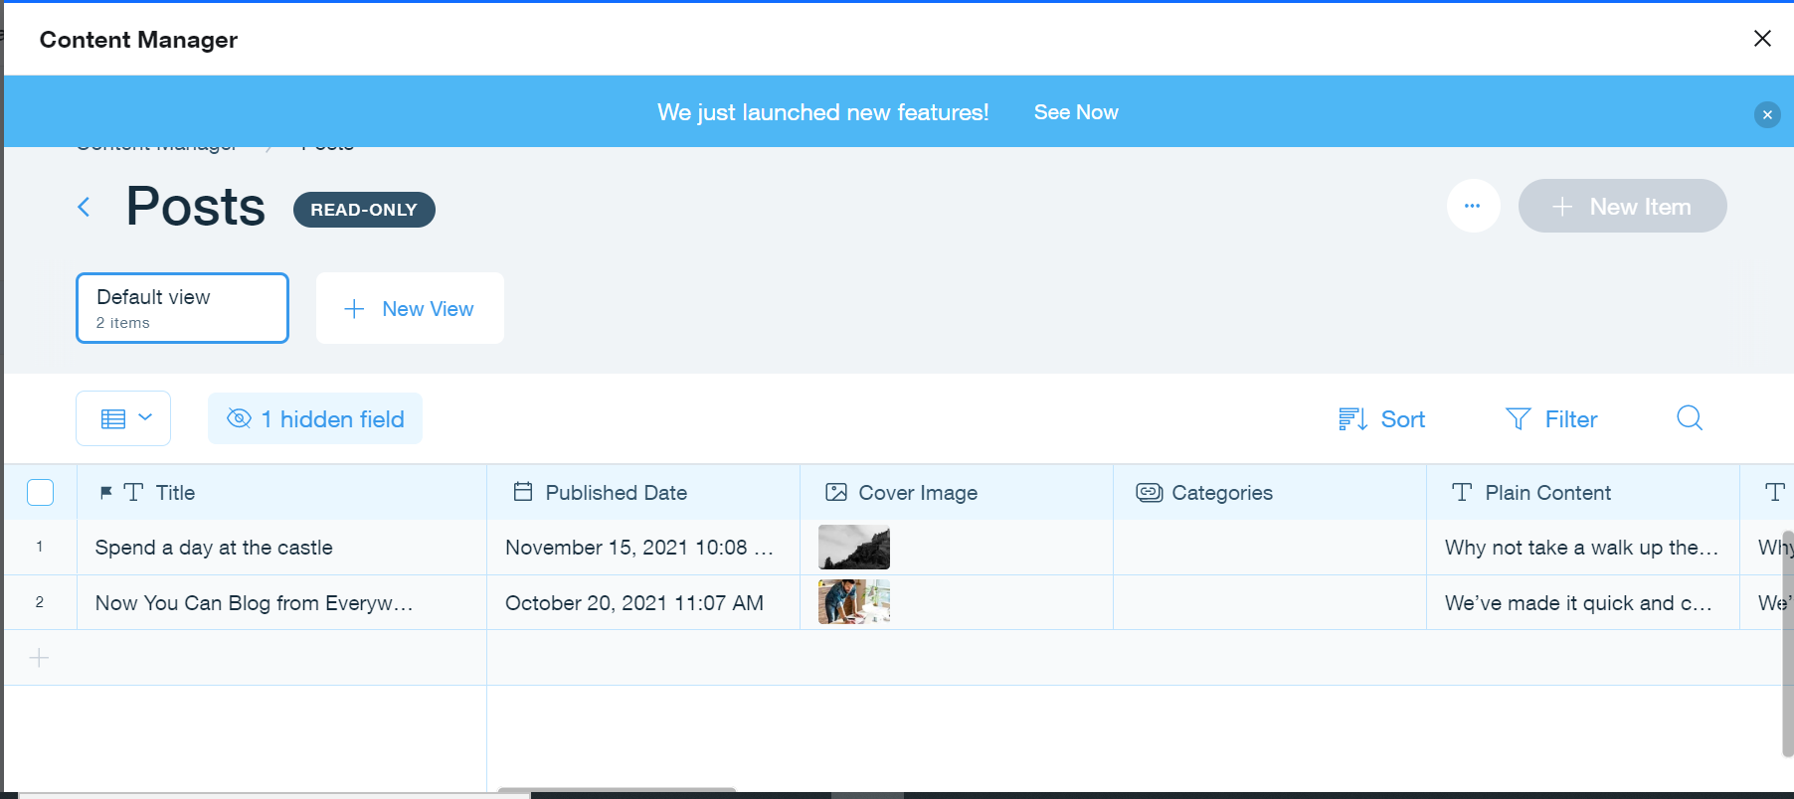

- Security: One example of website security is membership permissions. This screenshot shows where we can limit or allow different functionality to our blog for different users – own words for caption
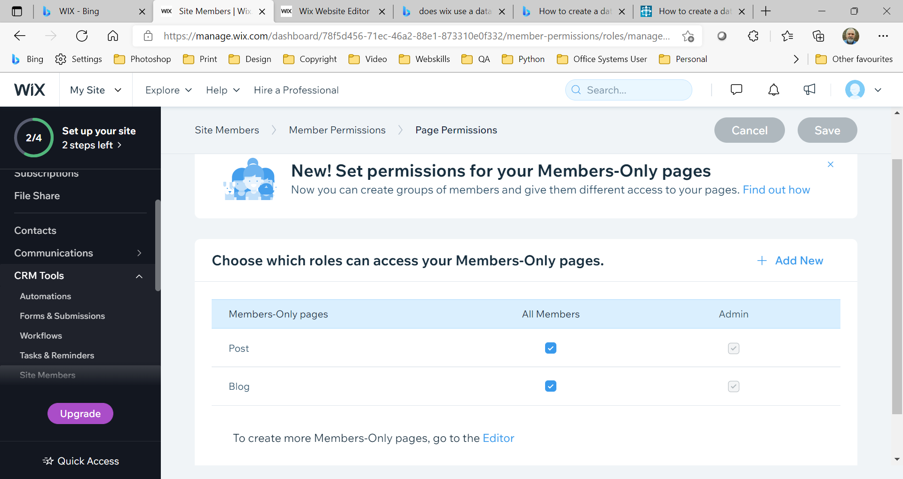
(25 Minutes)

Other components
- Domain name: register website name Most website hosting companies such as Wix, GoDaddy or Ionos will provide facilities to search for register and buy a domain name for your website. Below is a screenshot of how to get a domain name for your Wix site. – own words for caption
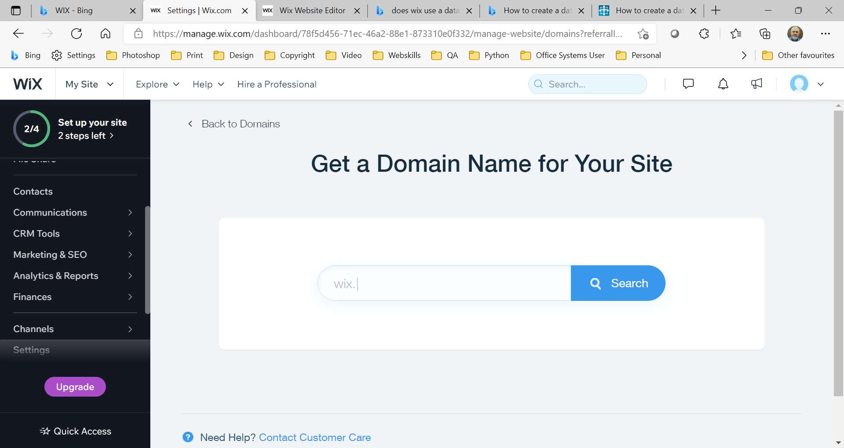

- Hosting: buy a space for website Website hosting companies offer a variety of plans for hosting your website depending on the size, features and add-ons you would like. These plans are very customizable but can quickly become expensive. You can often also purchase additional services such as design or security. Below is a screenshot of Wix plan choices. – own words for caption

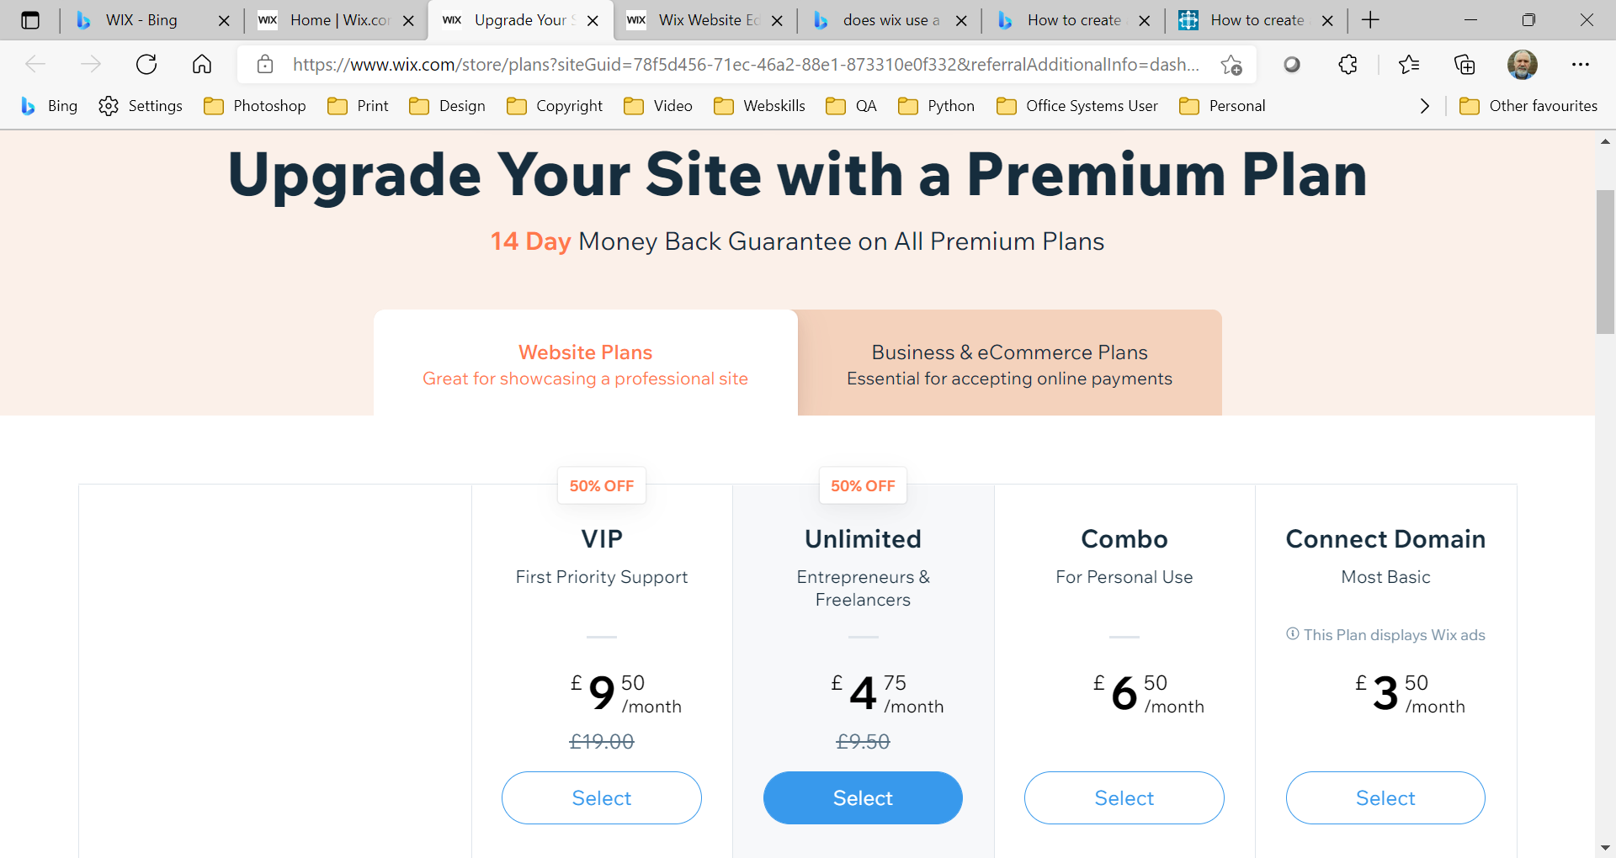
(10 minutes to complete )

Produce an implementation plan for a web-site

development project.

Write a paragraph explaining your implementation plan – see “timescale sheet”. Discuss how you have set out the key milestones, any considerations you have had to take into account, design choices, the planning time and process, coding time, testing, reflection and review, how you would handle additional functionality requests, how you would handle invoice delays or technical issues that arise etc. Do you have anything in the budget to cover 3rd party work if required. Do you have ongoing costs or management to take care of in the future. How will you handle customer relationships.
Here is a screenshot of my implementation plan

IMPLEMENT A WEBSITE FROM A DESIGN SPECIFICATION

4.1 Develop a fully functional website to meet requirements.

Follow along with tutor – adapting to own design
Here is a screenshot of my website


4.2 Test a website and review against requirements.

Compatibility Test
Manual Test: describe the steps you took to test your site
Online Test: describe the steps you took to test your site
https://comparium.app
http://browsershots.org/
https://www.browserling.com/

Link Test:
Manual Test: describe the steps you took to test your site
Online Test: describe the steps you took to test your site
https://www.brokenlinkcheck.com/
https://www.drlinkcheck.com/

Performance Test
https://www.webpagetest.org/
https://developers.google.com/speed/pagespeed/insights/
https://gtmetrix.com/
https://tools.pingdom.com/
Here is a screenshot of a website test result

